Book Report 1st Tri
Due October 8

For this tri’s book report, you will have 3 things to finish before the due date.

- Fill in the plot graph on the back of this paper. Include as many details as possible in the space allotted.
- Make a project. Do either A or B but NOT BOTH.
- Present the plot and the project to Mrs. Reid on October 8th.

Project choice A: CHARACTER
Make a “soda bottle character” by getting an empty 2 liter bottle and glue a head to it. (head can be styrofoam, paper mache, a balloon, etc.) Dress the character the way he/she would have been in the book. Be prepared to explain your character to Mrs. Reid and defend your choices.

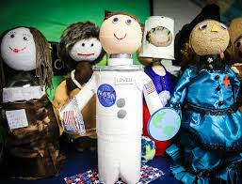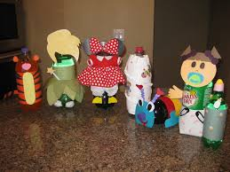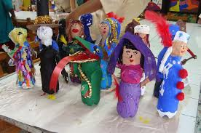

Project Choice B: SETTING
Make a diorama of the setting of the story. This can be done with any size box, but one that is approximately one foot long and eight inches high would be preferable. Include at least one character in the diorama. Be prepared to explain your setting to Mrs. Reid and defend your representation of it.

